Nalongsone Danddank Student ID : 14958950 StarID: jf3893pd

Email: [nalongsone.danddank@my.metrostate.edu](mailto:nalongsone.danddank@my.metrostate.edu)

**Metropolitan State University**

**ETHS 304-51 —Environmental Justice and Public Policy**

**Two Page Altered Book: Environmental Racism**

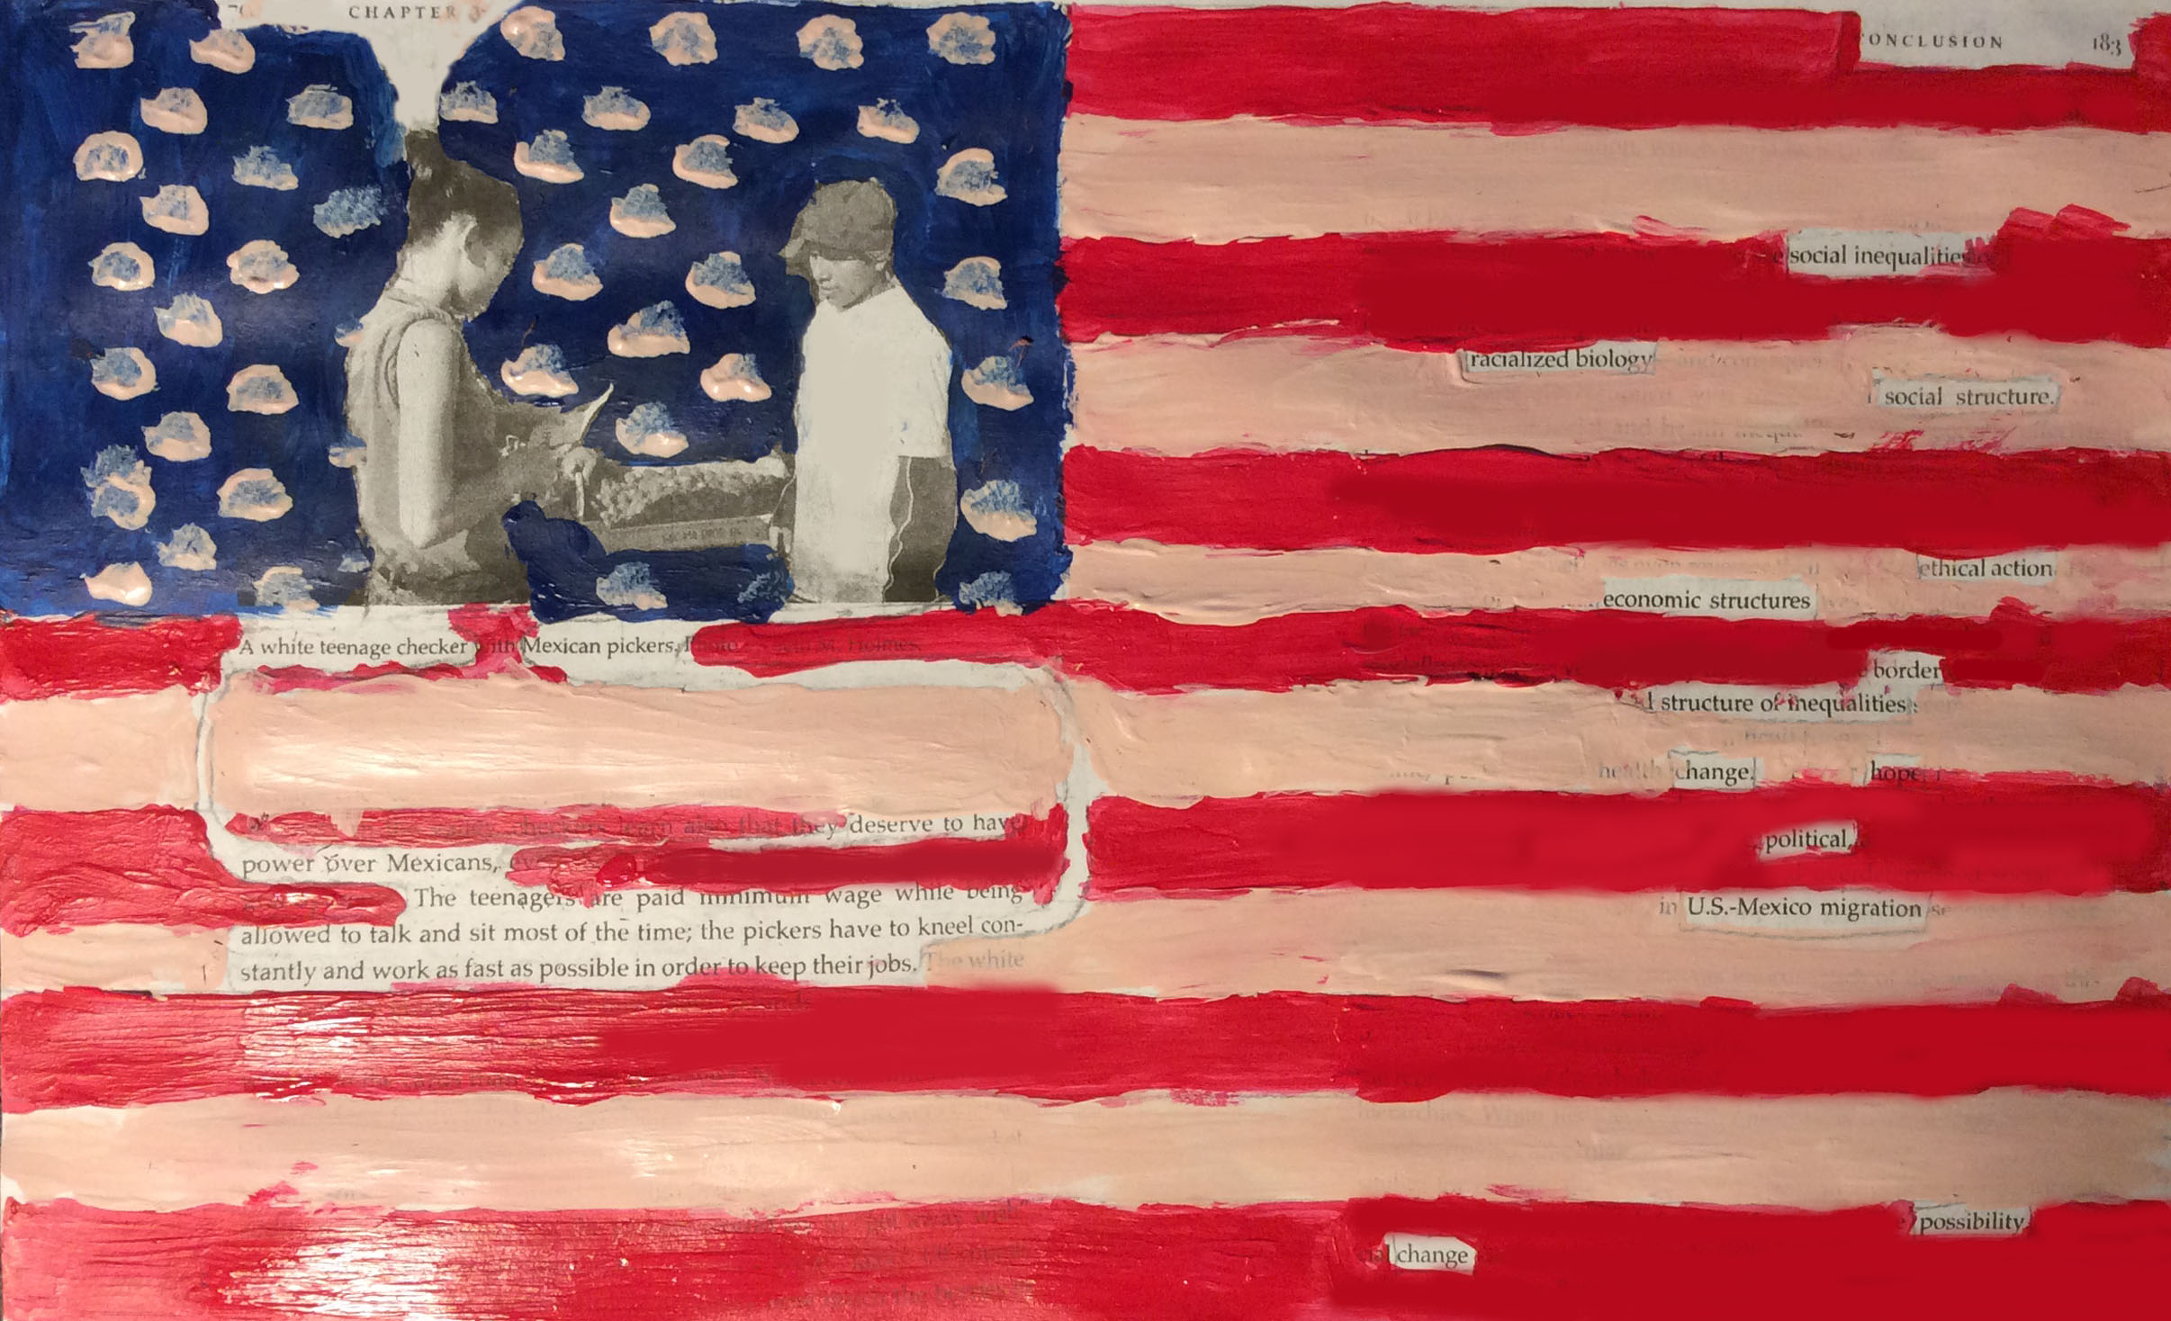

**Workplace in The U.S : White Teenager & Mexican Picker**

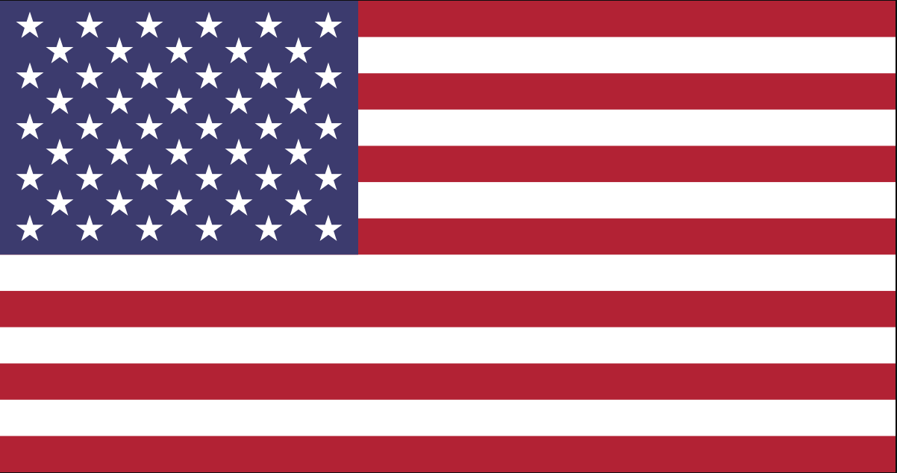

# The U.S Flag

Theme: Environmental racism.

My first page that I use in the Fresh Fruit, Broken Bodies Book is page 70 of chapter 3 this page includes the picture that I think it represents for nowadays situation of The U.S workplace. In the picture, Holmes shows and compares two workers who were born with different country and different skin color. The keys words that Holes said in this page and I show in the empty space of the painting means that, the white teenager girl checker work with Mexican pickers with more salary while being allowed to talk and sit most of the time; However, the pickers who is the man in the right of the picture, have to kneel constantly and work as fast as possible in order to keep their jobs. I think Holmes want to explain the real situation of environmental racism with comparing two people on the picture to show the social inequality that come from the people different background.

The second page that I choose is page 183 in chapter seven, Conclusion. In this page or this chapter, Holmes describes and provides some idea about possibilities for hope and change. I believe that after Holmes talks about his experience and some ideas through the whole book, he would like to provide some ideas to let these situation change. And the keys worlds that I show in the empty space of the 183 page like, “social inequalities”, “racialized biology”, “social structure”, “ethical action”, “economic structures”, border, structure of inequalities, change, hope, political, U.S-Mexico migration, possibility, change. Through these key words, I think Holmes like to explain that he want to change and improve the environment that inequality and racism.

I use these two pages of the book and try to paint like the U.S flag to demonstrate the environment racism which happen in the U.S. We can not ignore and let it happens anymore in our country and around the world.

Reference:

Holmes, Seth M., 1975-.*Fresh Fruit, Broken Bodies : Migrant Farmworkers in the United States. Berkeley* :University of California Press, 2013.